(Approx. 872 words)

Video Chatting Apps
Skype, Facebook Messenger, and Others
By Tom Burt, Vice-President, Sun City Summerlin Computer Club
www.scsscc.club
tomburt89134 (at) cox.net

While practicing “social distancing,” I got interested in ways to use video chatting to have face-to-face interaction with friends, family, and potentially with doctors (telemedicine) and that led to this article. Video chatting is a real-time video/audio conversation between two or more parties connected via the Internet. They use your device’s webcam, microphone, and speaker to create a virtual face-to-face interaction between you one or more other connected parties. These connections can be full audio and video, audio-only, or even just text messaging, depending on what hardware features are available.
We’ll start with an overview of some of the major video chatting apps and services and then delve into Facebook Messenger and Microsoft Skype in more detail to illustrate how it’s done.

Video Chatting Apps Overview
I found a couple of good articles describing the best free video chatting apps:
https://parade.com/1010666/jessicasager/best-video-chatting-apps/
https://www.cnet.com/news/7-free-video-chat-apps-to-use-if-youre-social-distancing/
At the top of the list was Apple’s FaceTime, which works for Mac and iOS devices, but not Android or Windows. The second was Facebook’s WhatsApp for Android and iOS devices (but not for Windows or macOS). High on the list was Facebook Messenger for smartphones, tablets, and computers. Also high was Microsoft Skype for smartphones, computers, tablets, smartwatches, and Xbox One. Two others of interest are Zoom and Webex. All of these have free versions as well as higher-end paid versions. There are links to the details of these in the articles referenced above.
Most video chatting services mediate the connections through dedicated web-based servers that can handle thousands of simultaneous connections. As a user, you set up an account with that service. Your login ID also serves as the “handle” to which other video callers connect. For instance, on Facebook Messenger, you use your existing Facebook ID and on Skype, you use your existing Microsoft ID. You can easily create accounts if you don’t already have them.
Some of the video chatting apps are implemented as web browser extensions. Others, including Skype and Facebook Messenger, have standalone client apps that run on your desktop.

What Hardware Do You Need?
Aside from some kind of computing device (smartphone, tablet, PC, Xbox) with a video display, the key requirements are a webcam, microphone, and speakers connected to or built into the computing device. Laptop PCs, All-in-One PCs, tablets, and smartphones normally have these built-in and also have the proper hardware drivers installed by the manufacturer. On desktop tower PCs the webcam, speakers, and microphone are usually separate add-ons. In all cases, it’s important to have the latest hardware drivers for your webcam, speakers, and microphone.

Facebook Messenger
Facebook Messenger is available on Windows, macOS, Android, and iOS. It also can run via a web browser. For Windows, I recommend getting the free Facebook Messenger app from the Microsoft Store. Once it’s installed, you can just launch it from the Start menu or a desktop icon. The first time you start it, you can configure and test your webcam, microphone, and speakers. It then asks you to login using your Facebook ID (usually your email address).
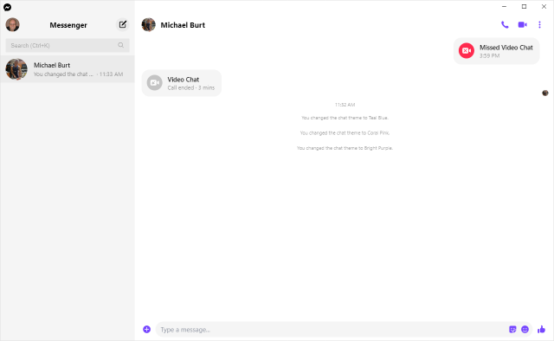
Facebook Messenger Windows App Main Screen
Once you’re logged in, you can search for other Facebook users (family, friends, business associates), select one and then click an icon in the upper right to initiate a video or an audio call to that person. If the other party accepts your call, the screen will show what the other party’s webcam is showing along with a small image of what your webcam is showing them. This helps you stay “on camera” during the chat. When you’re done, you can click an “end call” icon to close the connection.

Microsoft Skype
Skype is available on Windows 7, 8.1, and 10, Android, iOS, and the Xbox game console. It is a built-in app on Windows 10 and is updated automatically via Windows update. You can download it from the Microsoft download site as well as the Android and Apple app stores.
When you launch Skype, it will first walk you through configuring your webcam, microphone, and speakers. You can then log in using your Microsoft ID and password. Once logged in, you can search for other Skype users or type in the Skype ID of a user. Then you can initiate a video or an audio call by clicking the icons at the upper right or you can type text messages.
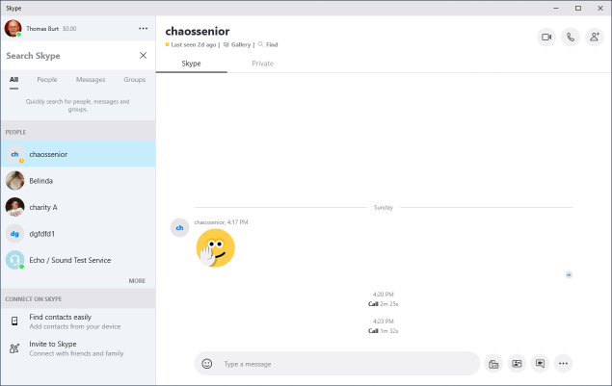
Microsoft Skype Windows App Main Screen
If the party you’re calling accepts the call, the screen will display what their webcam is seeing along with a small image of what your webcam is seeing. When you’re done, you can click an “end call” icon to close the connection.

Final Thoughts
As you can see, the Facebook Messenger and Skype desktop apps for Windows are very similar in layout and behavior. There’s a lot I haven’t touched on – especially chat’s involving more than two participants. You will probably have a better experience of your desktop device is using a wired Ethernet connection, but a strong WiFi signal should also be OK. The video chat is definitely more engaging with a large screen that you don’t have to hold.

